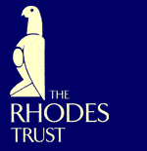

Sir Colin Lucas, Warden of Rhodes House,

in collaboration with the

Association of American Rhodes Scholars,
cordially invites you to attend
a gathering of Rhodes Scholars
for breakfast at the University Club of Chicago
Charter Room, 7th Floor
76 East Monroe Street, Chicago
on Friday, December 7, 2007
from 8:00 to 9:30 a.m.

RSVP by November 30, 2007
Helena.Snow@rhodeshouse.ox.ac.uk  Dress: business attire

